REST API

A REST API (also known as RESTful API) is an application programming interface (API or web API) that conforms to the constraints of REST architectural style and allows for interaction with RESTful web services.
what is API?
An API is a set of definitions and protocols for building and integrating application software. It’s sometimes referred to as a contract between an information provider and an information user—establishing the content required from the consumer (the call) and the content required by the producer (the response).
You can think of an API as a mediator between the users or clients and the resources or web services they want to get
What is REST?
API developers can implement REST in a variety of ways.
When a client request is made via a RESTful API, it transfers a representation of the state of the resource to the requester or endpoint. This information, or representation, is delivered in one of several formats via HTTP: JSON (Javascript Object Notation), HTML, XLT, Python, PHP, or plain text. JSON is the most generally popular file format to use .
Something else to keep in mind: Headers and parameters are also important in the HTTP methods of a RESTful API HTTP request, as they contain important identifier information as to the request's metadata, authorization, uniform resource identifier (URI), caching, cookies, and more. There are request headers and response headers, each with their own HTTP connection information and status codes.
REST technology is generally preferred to the more robust Simple Object Access Protocol (SOAP) technology because REST uses less bandwidth, simple and flexible making it more suitable for internet usage.
A request is sent from client to server in the form of a web URL as HTTP GET or POST or PUT or DELETE request
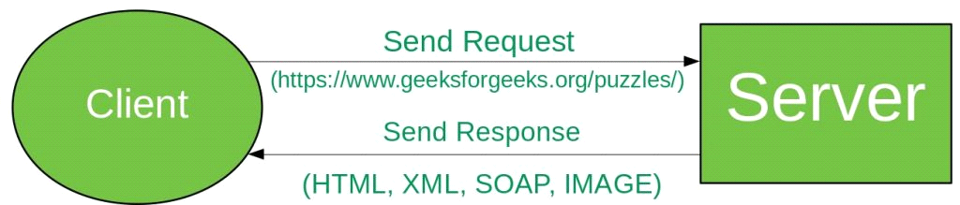
GET: The HTTP GET method is used to read (or retrieve) a representation of a resource. In the safe path, GET returns a representation in XML or JSON and an HTTP response code of 200 (OK). In an error case, it most often returns a 404 (NOT FOUND) or 400 (BAD REQUEST)
POST: The POST verb is most often utilized to create new resources. In particular, it’s used to create subordinate resources. That is, subordinate to some other (e.g. parent) resource. On successful creation, return HTTP status 201, returning a Location header with a link to the newly-created resource with the 201 HTTP status.
PUT: It is used for updating the capabilities. However, PUT can also be used to create a resource in the case where the resource ID is chosen by the client instead of by the server. In other words, if the PUT is to a URI that contains the value of a non-existent resource ID. On successful update, return 200 (or 204 if not returning any content in the body) from a PUT.
DELETE: It is used to delete a resource identified by a URI. On successful deletion, return HTTP status 200 (OK) along with a response body.
HEAD:
@HEAD maps to HTTP HEAD method.In REST HEAD is a method level annotation, this annotation indicates that the following method will respond to the HTTP HEAD request only. It is used to get only response status and headers information from the server but no body ( entity ).
Produces :
The @Produces annotation is used to specify the MIME media types or representations a resource can produce and send back to the client. If @Produces is applied at the class level, all the methods in a resource can produce the specified MIME types by default
@PATCH:
PATCH is a method of modifying resources where the client sends partial data that is to be updated without modifying the entire data.
@Path
The @Path annotation is used to specify the URI through which a resource and an API can be accessed. this annotation is present at the class level as well as the method level. It is mandatory to annotate a REST Web resource class with the @Path annotation.
The following method-level annotations are used to map an HTTP operation or command to an API.

@GET maps to the HTTP GET method.
@POST maps to HTTP POST method.
@PUT maps to HTTP PUT method.
@PATCH maps to HTTP PATCH method.
@DELETE maps to HTTP DELETE method.
@Consumes
The @Consumes() annotation specifies the list of media types consumed by a particular API or class. This annotation is optional at both the class and API levels. If it is present at both levels, the method-level annotation takes precedence. If the annotation is not present at any level, by default the "text/html" media type is returned.
Examples:
@Consumes("application/json")
@Consumes("application/xml")

EG: ___________________________________JAVA CONTROLLER___________________________
package com.exterro;
import javax.ws.rs.FormParam;
import javax.ws.rs.POST;
import javax.ws.rs.Path;
import javax.ws.rs.core.Response;
import org.json.simple.parser.ParseException;
@Path("/call")
public class Controls {
@POST
@Path("/hit")
public Response HitMe(@FormParam("B")String data) throws ParseException {
System.out.println("Inside !!!!");
System.out.println();
System.out.println("Invalid user!!!");
return Response.status(200).entity("Done").build();
}
}
____________________________________AJAX _________________________________________
function register(){
console.log("welcome")
alert("call!!!")
event.preventDefault();
var infos = {
name : $("#uname").val(),
age : $("#age").val(),
email:$("#email").val(),
phone:$("#phone").val(),
date : $("#date").val(),
password : $("#password").val(),
confirmpassword : $("#confirmPassword").val()
};
console.log("after data")
$.ajax({
type : "POST",
data: {B : JSON.stringify(infos)},
contentType:"appliction/Json",
url:"rest/call/hit",
success : function(B){
console.log("this is msg"+B);
alert("i am done!!!!");
}
});
console.log("data")
}
__________________________________________________________________________________
JAX-RS -PARAM
@QueryParam
@DefaultValue
@Context
@FormParam
@PathParam
@MatrixParam

What is Query String ?
It is basically a part of URL which contains the values in the key value form.
It specifies these values after the question mark(?) in the URL and multiple key values are separated by “&”.
eg:
http://sample.com?id=1&name=kb
we can see 2 key value pairs id=1 and name=kb

What is QueryParam?
It is same as Query string, but in JAX-RS we have the annotation to read this query string and that annotation name is “QueryParam”
We write it as @QueryParam.
eg:(@QueryParam(“id”) String id,@QueryParam(“name”) String name, . . . . )
We have add dependencies for Jersey servlet and Junit .
eg:
import javax.ws.rs.DefaultValue;
import javax.ws.rs.GET;
import javax.ws.rs.Path;
import javax.ws.rs.Produces;
import javax.ws.rs.QueryParam;
import javax.ws.rs.core.Response;
@Path("/userDetailsDefaultValueQueryParam")
public class DefaultValueQueryParamUserService {
@GET
@Produces("text/html")
public Response getUserDetails(@DefaultValue("John") @QueryParam("name") String name,@DefaultValue("NY") @QueryParam("state") String state,@DefaultValue("M") @QueryParam("gender") String gender){
String output =null;
String title=null;
if("M".equals(gender)){
title="Mr";
}
else{
title="Mrs";
}
if("AP".equals(state)){
output =title+" "+name+" is from INDIA country";
}
else if("NY".equals(state)){
output =title+" "+name+" is from USA country";
}
else{
output =title+" "+name+" is from Unknown country";
}
return Response.status(200).entity(output).build();
}
}

@DefaultValue:
In the above example
Sometimes we get the query parameters as null whenever they have not been passed in the URL,In that case,@DefaultValue annotation becomes handy.
It’s good to use Default values always for the Query Params.

@Context UriInfo:
We can also get the query parameters programmatically without using @QueryParam.
We just need to use @Conext UriInfo uriInfo as the method argument as below.
eg:
@GET
@Produces("text/html")
public Response getUserDetails(@Context UriInfo uriInfo){
String name=uriInfo.getQueryParameters().getFirst("name");
String state=uriInfo.getQueryParameters().getFirst("state");
String gender=uriInfo.getQueryParameters().getFirst("gender");
String output =null;
String title=null;

What is @FormParam ?
This annotation is used to bind the form values to method variables just like @QueryParam but @QueryParam will work only if client makes a GET request.
If client makes a POST request, then all the parameters submitted by the POST request can be accessed using @FormParam at the method parameters level.
eg:
import java.util.List;
import javax.ws.rs.FormParam;
import javax.ws.rs.POST;
import javax.ws.rs.Path;
import javax.ws.rs.Produces;
import javax.ws.rs.core.Response;
@Path("/user")
public class FormParamUserService {
@POST
@Path("/create")
@Produces("text/html")
public Response getUserDetails(@FormParam("name") String name,@FormParam("state") String state, @FormParam("age") String age,@FormParam("skill") List<String> skills)
{ //Service call to save Data in DB
String output =name+" from the state "+state+ " with the age "+age+ "and with the skills "
+skills+" is created ";
return Response.status(200).entity(output).build();
}
}

What is PathParam ?
It is the annotation defined in JAX-RS specification which is used to resolve the values passed in the URL and inject them to the method.
Values are passed in the URL with @Path expression.
@Path expression is just the parameters which are enclosed in curly braces in URL.
This annotation will be used at the method argument level.
Example:
http://sample.com/user/{id}
Here “id” is passed as part of the URL with @Path expression.
and hence “id” is a path parameter in this URL.
For the above example, we can use @PathParam in method argument as below
(@PathParam(“id”) String id)
import javax.ws.rs.GET;
import javax.ws.rs.POST;
import javax.ws.rs.Path;
import javax.ws.rs.PathParam;
import javax.ws.rs.Produces;
import javax.ws.rs.core.Response;
@Path("/user")
public class PathParamUserService {
@GET
@Path("{id}")
@Produces("text/html")
public Response getUserDetails(@PathParam("id") String id){
//Service call to Get user Data based on id from DB
String output ="user details for id "+id+ ": Name:John, state : New jersey,Country:USA, age:45";
return Response.status(200).entity(output).build();
}

__________________________________________________________________________________AJAX
AJAX = Asynchronous JavaScript And XML.
AJAX is not a programming language.
AJAX just uses a combination of:
A browser built-in XMLHttpRequest object (to request data from a web server)
JavaScript and HTML DOM (to display or use the data)
AJAX applications might use XML to transport data, but it is equally common to transport data as plain text or JSON text.
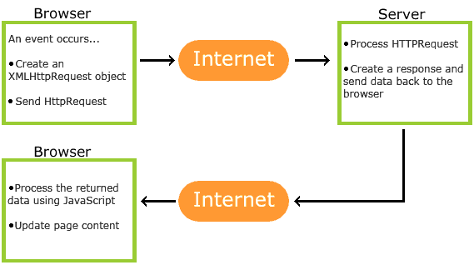
AJAX allows web pages to be updated asynchronously by exchanging data with a web server behind the scenes. This means that it is possible to update parts of a web page, without reloading the whole page.
JQuery:
It was designed to handle Browser Incompatibilities and to simplify HTML DOM Manipulation, Event Handling, Animations, and Ajax.
For more than 10 years, jQuery has been the most popular JavaScript library in the world.
jQuery is a lightweight, "write less, do more", JavaScript library.
The purpose of jQuery is to make it much easier to use JavaScript on your website.
jQuery takes a lot of common tasks that require many lines of JavaScript code to accomplish, and wraps them into methods that you can call with a single line of code.

The jQuery library is a single JavaScript file, and you reference it with the HTML <script> tag (notice that the <script> tag should be inside the <head> section):
<head>
<script src="jquery-3.6.4.min.js"></script>
</head>
_________________________(OR )______________________
jQuery CDN
<head>
<script src="https://ajax.googleapis.com/ajax/libs/jquery/3.6.4/jquery.min.js"></script>
</head>
____________________________________________________
Basic syntax is: $(selector).action()
Examples:
$(this).hide() - hides the current element.
$("p").hide() - hides all <p> elements.
_______________________________
jQuery Selectors
jQuery selectors allow you to select and manipulate HTML element(s).jQuery selectors are used to "find" (or select) HTML elements based on their name, id, classes, types, attributes, values of attributes and much more.
i) The element Selector:
The jQuery element selector selects elements based on the element name.
eg:
$(document).ready(function(){
$("button").click(function(){
$("p").hide();
});
});
ii)The #id Selector:
The jQuery #id selector uses the id attribute of an HTML tag to find the specific element.
eg:
$(document).ready(function(){
$("button").click(function(){
$("#test").hide();
});
});
iii) The .class Selector
The jQuery .class selector finds elements with a specific class.
eg:
$(document).ready(function(){
$("button").click(function(){
$(".test").hide();
});
});
JQuery html operations :
- Jquery get
- jquery set
- jquery add
- jquery remove
Passing the parameter using jquery to
eg:
function register(){
console.log("welcome")
alert("call!!!")
event.preventDefault();

var infos = {
name : $("#uname").val(),
age : $("#age").val(),
email:$("#email").val(),
};
console.log("after data")
$.ajax({
type : "POST",
data: {B : JSON.stringify(infos)},
contentType:"appliction/Json",
url:"rest/call/hit",
success : function(B){
console.log("this is msg"+B);
alert("i am done!!!!");
}
});
console.log("data")
}

